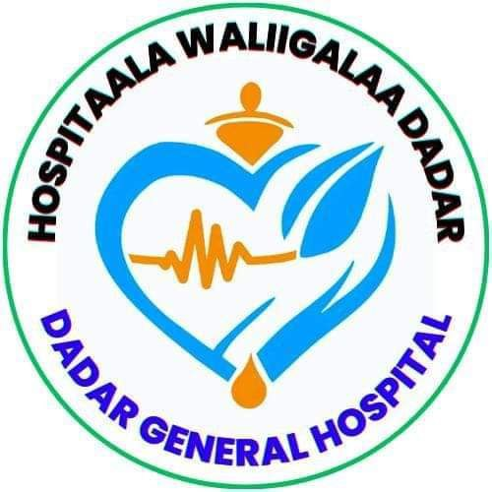

DEDER GENERAL HOSPITAL
Terms of Reference (TOR)
for
Outbreak Response Committee (ORC)

£

July 2017EC,
Deder, Ethiopia
Table of Contents
1. Background 3
2. Purpose 3
3. Objectives 3
4. Scope 4
5. Composition 4
6. Roles and Responsibilities 5
7. Meeting Frequency 5
8. Reporting and Accountability 6
9. Operational Tools and Documents 6
10. Duration 6
11. Review and Amendments 6
Signatures and Approvals 7

1. Background
Deder General Hospital serves a large and diverse population and routinely provides care for patients with communicable diseases. To ensure timely and effective management of infectious disease outbreaks such as COVID-19, tuberculosis (TB), measles, cholera, and others, a multidisciplinary Outbreak Response Committee (ORC) is established under the oversight of the hospital leadership and the Infection Prevention and Control (IPC) Unit.

2. Purpose
The Outbreak Response Committee is responsible for planning, coordinating, executing, and reviewing all activities related to outbreak detection, containment, and recovery. It ensures a coordinated hospital-wide response to minimize transmission risks to patients, healthcare workers, and the community.

3. Objectives
- Early detection, verification, and classification of outbreak events.
- Rapid containment of infection spread through triage, isolation, and IPC enforcement.
- Mobilization of resources including personnel, PPE, and communication.
- Coordination of surveillance, reporting, and liaison with the public health authorities.
- Review of outbreak management and updating preparedness protocols.

4. Scope
This TOR applies to all units and departments within Deder General Hospital. It is activated in the event of:
- Suspected or confirmed outbreak within the facility.
- Notification from the Zonal or Woreda Health Office of a local outbreak.
- Hospital participation in regional or national outbreak response initiatives.

5. Composition
No. | Name | Position | Role in ORC
1 | Dr. Deresa Gosa | Medical Director | Chairperson
2 | Mr. Abrahim Tahir | IPC Focal Person | Secretary & Technical Lead
3 | Obbo Hamza Jamal | Matron | Member – Nursing Liaison
4 | Mr. Alamudin Usmail | Lab Head | Member – Diagnostic Oversight
5 | Mr. Ballisa Usman | Pharmacy Head | Member – IPC Supply Chain
6 | Obbo Kadir Mohammed | Sanitation Head | Member – Environmental Hygiene
7 | Mr. Dine Abdalla | Finance Rep | Member – Budget & Logistics
8 | Sr. Dasta Teffasa | Housekeeping Supervisor | Member – Cleaning Compliance
9 | Mr. Jabir Mohammed | Emergency Rep | Member – Triage Coordination
10 | Dr. Dawid Seifu | IPD Director | Member – Inpatient Oversight
11 | Public Health Officer | External Liaison | Technical/Regulatory Support

6. Roles and Responsibilities
Area | Responsibility
Leadership | Activate ORC upon outbreak detection; enforce hospital-wide compliance.
IPC Enforcement | Implement and monitor all IPC protocols including PPE use, hand hygiene, and isolation precautions.
Case Verification | Review and confirm reported cases; define and adapt case definitions.
Triage & Isolation | Supervise screening stations and isolation rooms.
Surveillance | Collect, validate, and analyze case data; manage contact tracing.
Resource Mobilization | Request and distribute IPC supplies; reassign staff as needed.
Communication | Issue internal alerts and external reports to health authorities.
Training | Conduct emergency drills and just-in-time training.
Review | Lead post-outbreak evaluation and update preparedness plans.

7. Meeting Frequency
- Emergency Outbreak Meeting: Within 24 hours of confirmed/suspected outbreak.
- Routine Review Meeting: Quarterly (for preparedness planning).
- Debriefing: Within one week of outbreak resolution or simulation drill.

8. Reporting and Accountability
- Reports to the Hospital CEO and Governing Board.
- Submits outbreak updates to the Zonal/Woreda Health Office.
- Provides weekly updates during active outbreaks and quarterly summaries for routine reviews.

9. Operational Tools and Documents
- Outbreak Case Log Sheet
- Contact Tracing Register
- Situation Report (SitRep) Template
- PPE Distribution Tracker
- Post-Outbreak Review Report Format
- Updated SOPs for Triage and Isolation

10. Duration
This committee remains permanently active with standing members and is formally activated during any confirmed or suspected outbreak or emergency.

11. Review and Amendments
This TOR shall be reviewed annually or following a major outbreak. Amendments shall be approved by the Hospital Management Team and documented accordingly.

Signatures and Approvals
Name | Position | Signature | Date
Dr. Deresa Gosa | Medical Director | ____________ | __________
Mr. Abrahim Tahir | IPC Focal Person | ____________ | __________
Ato Nuredin Yigezu Tilahun | CEO | ____________ | __________

